**DSA ASSIGNMENT-1**

**TANISHA KARMAKAR**

**21051950**

**CSE 37**

**Q1. WAP for entering a sparse matrix and covert in triplet format.**

#include<stdio.h>

int main()

{

int M[100][100], m, n, k=1, size=0;

printf("Enter number of rows: ");

scanf("%d", &m);

printf("Enter number of columns: ");

scanf("%d", &n);

for(int i=0; i<m; i++){

for(int j=0; j<n; j++){

printf("Enter element [%d][%d]: ", i+1, j+1);

scanf("%d", &M[i][j]);

if (M[i][j] != 0)

size++;

}

}

printf("The matrix is \n");

for (int i = 0; i < m; i++) {

for (int j = 0; j < n; j++) {

printf(" %d ",M[i][j]);

}

printf("\n");

}

int T[size+1][3];

T[0][0]=m;

T[0][1]=n;

T[0][2]=size;

for(int i=0; i<m; i++){

for(int j=0; j<n; j++){

if (M[i][j]!=0)

{

T[k][0]=i;

T[k][1]=j;

T[k][2]=M[i][j];

k++;

}

}

}

printf("Triplet representation of the matrix is \n");

for (int i=0; i<size+1; i++)

{

for (int j=0; j<3; j++)

printf(" %d ", T[i][j]);

printf("\n");

}

return 0;

}

**Output:**

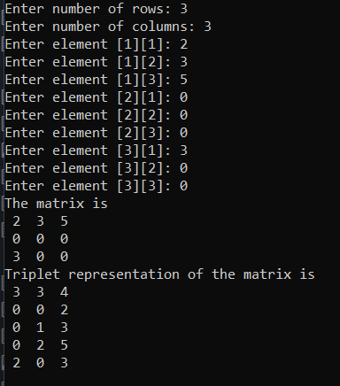

**Q2. WAP to find the largest element of a sparse matrix using triplet format.**

#include<stdio.h>

int main()

{

int M[100][100], m, n, k=1, size=0, largest;

printf("Enter number of rows: ");

scanf("%d", &m);

printf("Enter number of columns: ");

scanf("%d", &n);

for(int i=0; i<m; i++){

for(int j=0; j<n; j++){

printf("Enter element [%d][%d]: ", i+1, j+1);

scanf("%d", &M[i][j]);

if (M[i][j] != 0)

size++;

}

}

printf("The matrix is \n");

for (int i = 0; i < m; i++) {

for (int j = 0; j < n; j++) {

printf(" %d ",M[i][j]);

}

printf("\n");

}

int T[size+1][3];

T[0][0]=m;

T[0][1]=n;

T[0][2]=size;

for(int i=0; i<m; i++){

for(int j=0; j<n; j++){

if (M[i][j]!=0)

{

T[k][0]=i;

T[k][1]=j;

T[k][2]=M[i][j];

k++;

}

}

}

printf("Triplet representation of the matrix is \n");

for (int i=0; i<size+1; i++)

{

for (int j=0; j<3; j++)

printf(" %d ", T[i][j]);

printf("\n");

}

for (m=1; m<(size+1); m++){

if (T[m][2]>T[m+1][2]){

largest=T[m][2];

}

}

printf("The largest element is %d", largest);

return 0;

}

**Output:**

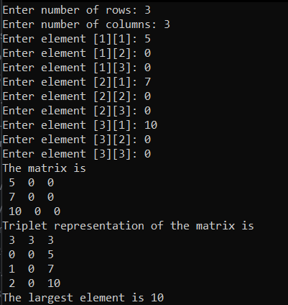

**Q3.  WAP to check if a matrix is lower triangular or upper triangular matrix.**

#include<stdio.h>

int main()

{

int m[100][100], r, c, flag=0, temp2=0, temp3=0;

printf("Enter no. of rows: ");

scanf("%d", &r);

printf("Enter no. of cols: ");

scanf("%d", &c);

for( int i=0; i<r; i++){

for( int j=0; j<c; j++){

printf("Enter Element for [%d][%d]: ", i+1, j+1);

scanf("%d", &m[i][j]);

}

}

printf("The matrix is \n");

for( int i = 0; i < r; i++) {

for (int j = 0; j < c; j++) {

printf(" %d \t",m[i][j]);

if (i==j && m[i][j]==0)

flag=1;

}

printf("\n");

}

if (r==c)

{

for (int i=0;i<r;i++)

{

for (int j=0;j<c;j++)

{

if (flag==1)

printf("Wrong Input");

else

{

if(i>j && m[i][j]!=0)

temp2++;

else if(j>i && m[i][j]!=0)

temp3++;

}

}

}

if (temp2==0 && temp3==0)

printf("Both Upper and Lower Triangular Matrix");

else if(temp2==0)

printf("Upper Triangular Matrix");

else if(temp3==0)

printf("Lower Triangular Matrix");

else

printf("Not of any type");

}

else

printf("Wrong Input");

return 0;

}

**Output:**

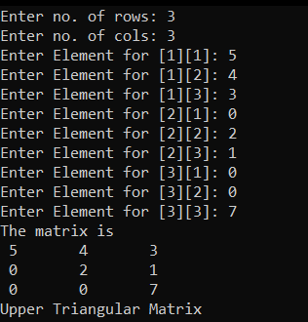

**Q4. WAP for finding the transpose of a sparse matrix using triplet format.**

#include<stdio.h>

#include<stdlib.h>

int main(){

int l = 0, n = 3;

// int sparse[3][3] = {

// {2, 0, 0},

// {0, 0, 1},

// {0, 3, 9}

// };

int sparse[3][3];

for(int i = 0; i < n; i++){

for(int j = 0; j < n; j++){

printf("%d %d = ", i, j);

scanf("%d", &sparse[i][j]);

if(sparse[i][j] != 0)

l++;

}

}

int triplet[l+1][3];

int k = 1;

triplet[0][0] = 3;

triplet[0][1] = 3;

triplet[0][2] = l;

for(int i = 0; i < n; i++){

for(int j = 0; j < n; j++){

if(sparse[i][j] != 0){

triplet[k][0] = i;

triplet[k][1] = j;

triplet[k][2] = sparse[i][j];

k++;

}

}

}

int transpose[l+1][3];

transpose[0][0] = 3;

transpose[0][1] = 3;

transpose[0][2] = l;

for(int i = 1; i < l+1; i++){

transpose[i][0] = triplet[i][1];

transpose[i][1] = triplet[i][0];

transpose[i][2] = triplet[i][2];

}

for(int i = 0; i < l+1; i++){

for(int j = 0; j < 3; j++){

printf("%d ", transpose[i][j]);

}

printf("\n");

}

return 0;

}

**Output:**

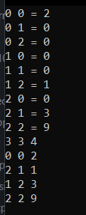

**Q5. WAP for addition of two sparse matrix using triplet format.**

#include<stdio.h>

#include<stdlib.h>

int main(){

int l1 = 0, l2 = 0, n = 3;

// int l1 = 4, l2 = 4, n = 3;

// int sparse1[3][3] = {

// {2, 0, 0},

// {0, 0, 1},

// {0, 3, 9}

// };

// int sparse2[3][3] = {

// {2, 0, 0},

// {0, 0, 1},

// {3, 3, 0}

// };

int sparse1[3][3];

printf("Enter first matrix: \n");

for(int i = 0; i < n; i++){

for(int j = 0; j < n; j++){

printf("%d %d = ", i, j);

scanf("%d", &sparse1[i][j]);

if(sparse1[i][j] != 0)

l1++;

}

}

int triplet1[l1+1][3];

int k = 1;

triplet1[0][0] = 3;

triplet1[0][1] = 3;

triplet1[0][2] = l1;

for(int i = 0; i < n; i++){

for(int j = 0; j < n; j++){

if(sparse1[i][j] != 0){

triplet1[k][0] = i;

triplet1[k][1] = j;

triplet1[k][2] = sparse1[i][j];

k++;

}

}

}

printf("Enter second matrix: \n");

int sparse2[3][3];

for(int i = 0; i < n; i++){

for(int j = 0; j < n; j++){

printf("%d %d = ", i, j);

scanf("%d", &sparse2[i][j]);

if(sparse2[i][j] != 0)

l2++;

}

}

int triplet2[l2+1][3];

k = 1;

triplet2[0][0] = 3;

triplet2[0][1] = 3;

triplet2[0][2] = l2;

for(int i = 0; i < n; i++){

for(int j = 0; j < n; j++){

if(sparse2[i][j] != 0){

triplet2[k][0] = i;

triplet2[k][1] = j;

triplet2[k][2] = sparse2[i][j];

k++;

}

}

}

int triplet[l1+l2+1][3];

k = 1;

triplet[0][0] = 3;

triplet[0][1] = 3;

triplet[0][2] = l1+l2;

int i = 1, j = 1, I = 1;

while((i < l1+1) || (j < l2+1)){

// printf("%d %d \n", i, j);

if(triplet1[i][0] < triplet2[j][0]){

triplet[I][0] = triplet1[i][0];

triplet[I][1] = triplet1[i][1];

triplet[I][2] = triplet1[i][2];

I++;

i++;

}

else if(triplet1[i][0] > triplet2[j][0]){

triplet[I][0] = triplet2[j][0];

triplet[I][1] = triplet2[j][1];

triplet[I][2] = triplet2[j][2];

I++;

j++;

}

else if(triplet1[i][0] == triplet2[j][0]){

if(triplet1[i][1] == triplet2[j][1]){

triplet[I][0] = triplet1[i][0];

triplet[I][1] = triplet1[i][1];

triplet[I][2] = triplet1[i][2] + triplet2[j][2];

I++;

i++;

j++;

}

else if(triplet1[i][1] < triplet2[j][1]){

triplet[I][0] = triplet1[i][0];

triplet[I][1] = triplet1[i][1];

triplet[I][2] = triplet1[i][2];

I++;

i++;

}

else if(triplet1[i][1] > triplet2[j][1]){

triplet[I][0] = triplet2[i][0];

triplet[I][1] = triplet2[j][1];

triplet[I][2] = triplet2[j][2];

I++;

j++;

}

}

}

// for(int i = 0; i < l1+1; i++){

// for(int j = 0; j < 3; j++){

// printf("%d ", triplet1[i][j]);

// }

// printf("\n");

// }

// for(int i = 0; i < l2+1; i++){

// for(int j = 0; j < 3; j++){

// printf("%d ", triplet2[i][j]);

// }

// printf("\n");

// }

printf("Addition of both triplets: \n");

for(int i = 0; i < I; i++){

for(int j = 0; j < 3; j++){

printf("%d ", triplet[i][j]);

}

printf("\n");

}

return 0;

}

**Output:**

